Maerdy Wind Fund
Application Form

Issued to: Public
Issued: 12.6.23
Status: Final v11
Filename: MWF Apln Form v11 120623.docx
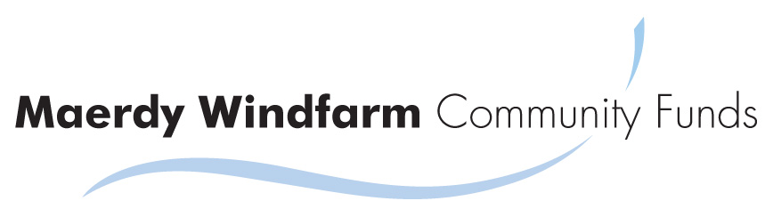
maerdywindfund.co.uk
22 West View
Milborne Port
Sherborne
DT9 5EJ
Maerdy Windfarm Community Funds Ltd

What to Do
1. Scheme Guidance - Read the Scheme Guidance and Standard Terms and Conditions of a Grant Available on the fund website www.maerdywindfund.co.uk.
2. A4 Bid Poster- Prepare a bid poster for the public – see examples on the fund website.
3. Application Form - Complete this application form.

Application Form
This is a Microsoft word document. Please complete all the input fields which will expand to fill your content. This section of the application form will be published. Should any information be sensitive and you not wish it to be published, please advise us.

1 Name of Applicant (Organisation or Individual).

2 How much? (How much are you applying for).

3 What on? (Please include a budget for all individual items that make up 10% or more of the total.).

4 Benefits to you?

5 Wider benefits to the community?

6 Are you eligible to reclaim VAT? (If yes, we can advance the full amount including the VAT, but you must repay this to the Fund when you get the VAT refund.)

7 Breakdown of cost Please provide a breakdown of elements of the cost that are grater than £100. You are welcome to provide this as a seprate budget, or spreadsheet if easier. Additionally, you must provide copies of at least one third-party quote or weblink for every item over £100, and at least two quotes for any item over £1,000.

8 Other Funding - Are you seeking monies for the same project from elsewhere? (You can do this, but must repay to the Fund excess funding you receive from alternative sources.)

9 What alternative sources of funding have you considered and why are these not successful?

10 When will you spend the money? (Grants will be awarded in January 2024 and you have up to two years to spend the funding.)

11 What other factors are necessary for grant expenditure to take place? (For example; there may be other funding you need, or a planning permission, etc.)

12 How will the benefits of the grant be sustained after the funding has finished? (For example, if it is a capital item, is there ongoing cost such as maintenance or rent, or if operational does similar expenditure need to be found every year?)

13 Any other information you wish to provide

Contact Details
Name of applicant (individual or organisation, as per Section 2.1)
Type of organistion (if applicant is organisation)
Date of Birth ((if applicant is individual)
Address
Primary contact details (the person we will be dealing with)
Full name
Position (if applicable for an organisation)
Telephone
Email (Please note we only communicate by email and you must provide an email address)
Address (Only if contact address is different to organisation address above)
Secondary contact details (If an organisation please provide details of the most senior offical if different to the primary contact)
Full name
Position
Telephone
Email
Address (Only if contact address is different to organisation address above)

Check list and Declaration
Bid Poster
Please refer to example Bid Poster in the Scheme Guidance and confirm all the following are included:
Organisation Name
Project title
Amount of grant application
Needs and benefits of project to YOU
What the money will actually be spent on
Description of your organisation
Needs and benefits of project to COMMUNITY
Contact details for public enquiries
Grant category you are applying in
Poster is good quality resolution, especially images
A4 size, Portrait orientation

Application Form
Every question is answered
Budget provided
Copies of at least one third party quotes for each cost elements over £100 provided and two quotes for each cost element over £1,000.

Legal Declarations
I am applying on behalf of myself or I am authorised by the organisation named to submit this application.
The contents of the application form and bid poster are accurate and true.
I/We understand that any seriously misleading statements or knowingly withheld information, could make our application invalid and we will be liable to repay any funds.
I/We have read the standard terms and conditions of a grant (available on website) and confirm our willingness to agree to these should we be awarded a grant.
I/We agree with the data protection clause below.
I/We accept that provision of any grant is at the sole and absolute discretion of the administrators and the basis for any grant decision may change without prior notice and we will not legally challenge, pursue enforcement or make any legal claim against the Fund.

Signature
Name
Position (if organisation)
For and on behalf of organisation (if applicable)

Send
That’s it! Please send your
i) completed application form (word document or PDF),
ii) supporting materials (Budget, Quotes, etc) and
iii) bid poster (PDF)
via email to to enquiries@maerdywindfund.co.uk by 30th September 2023 at the latest. We strongly recommend you submit as early as possible, and suggest 2 weeks before the deadline, so that we can advise you of any failings in your application and there is time to address these. If your application is not valid by 30th September 2023 we cannot accept it.
If absolutely necessary we will accept postal versions to: Maerdy Wind Fund, 22 West View, Milborne Port, Sherborne, DT9 5EJ, but all communication by us will be by email.

What next?
We will acknowledge receipt of your application within one week by email. If you have not heard from us please make contact to ensure your application has been received.

Data protection
If you have applied for, or hold a grant with us, we will use the information you give us during assessment and during the lifetime of any funding to administer and analyse grants and for our own research purposes.
Unless speciifally agreed otherwise with you we may give copies of all or some of this information to individuals and organisations we consult when assessing applications, administering the programme, monitoring funding and evaluating funding processes and impacts. These organisations may include accountants, external evaluators and other organisations or groups involved in delivering the project.
We may also share information with government or other organisations and individuals with a legitimate interest in grants or specific funding programmes, or for the prevention and detection of crime.
The Maerdy Wind Fund is subject to a public vote and therefore involves general public publicity. We will not share your personal details on the declaration page, however, if there is any other information in this application form or in subsequent correspondence that you do not wish to be made available to the general public then you must advise us.
We might use personal information provided by you in order to conduct appropriate identity checks. Personal information you provide may be disclosed to a credit reference or fraud prevention agency, which may keep a record of that information. If false or inaccurate information is provided in a funding application and fraud is identified, details will be passed to fraud prevention agencies to prevent fraud and money laundering.

