**Maerdy Wind Fund**

**Scheme Guidelines**

Issued to: Public

Issued: 22.06.25

Status: Final v15

Filename:

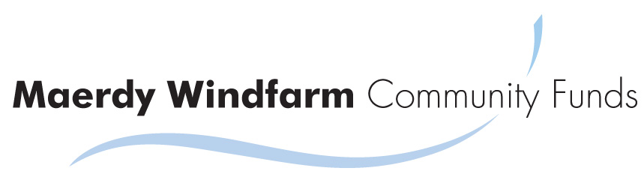

Maerdywindfund.co.uk

22 West View  
Milborne Port  
Sherborne  
DT9 5EJ

Maerdy Wind Fund CIC,   
Treorchy Wind Fund CIC  
Maerdy Windfarm Community Funds Ltd

# Contents

Contents 1

1. Introduction 2

2. Background to the Fund 3

3. Applying 4

4. The Public Vote 10

5. You’ve Been Awarded a Grant 14

6. Provisions 16

7. Contact 17

# Introduction

If you are interested in receiving funding from the Maerdy Wind Fund please:

1. Read the Scheme Guidance (this document)
2. Produce a Bid Poster (see the website for examples)
3. Complete an Application Form (available on the website)

# Background to the Fund

The Maerdy Wind Fund is funded by the operating revenues from the Maerdy Windfarm. This is an eight turbine windfarm built in 2013 at the top of the Rhondda, on land between Maerdy and Treorchy. The wind fund began in 2013 and will continue until the windfarm is decommissioned, which is expected to be about 2038.

Grants are issued every two years. Applications are invited from organisations and individuals with few restrictions on purpose or applicant. The objective to be as accessible as possible.

Applicants prepare a bid poster which is published on the Fund website. The public are invited to review the applications and to vote for their favourite ones. The projects with the most public votes receive the funding. Applicants have two years to implement their project. Grantees produce reports photos and videos of their project which are published on the fund website.

This document provides guidance on the scheme. Further copies are available from the fund website. The document will be updated from time to time; please check the website for the latest version.

# Applying

## What is the purpose of the fund?

The objectives of the Maerdy Wind Fund are to benefit the local and wider community of Maerdy.

## How much money is available?

£67,500 is available for 2025 (£65,000 in 2023). There are five categories of grant available; £500, £1,000, £2,500, £5,000 and £10,000. The table below shows the number of grants available in each category. If the number of applicants is exactly the same as the last fund in 2023, the subscription rates will be as shown. Of course there may be fewer or more applicants. Based on 2025 application rates there is a 1 in 4 chance of obtaining the £10,000 grant. For the £500 grants, more are offered than were applied for in 2023.

|  |  |  |  |  |
| --- | --- | --- | --- | --- |
| **Maerdy 2025** |  |  |  |  |
| **Grant category** | **No. Grants Available** | **TOTAL Available** | **Forecast Qualifying Applicants (2023)** | **Subscription Rate** |
| £500 | 12 | £6,000 | 10 | 83% |
| £1,000 | 9 | £9,000 | 17 | 189% |
| £2,500 | 5 | £12,500 | 8 | 160% |
| £5,000 | 4 | £20,000 | 13 | 325% |
| £10,000 | 2 | £20,000 | 8 | 400% |
| Total | 32 | £67,500 | 56 |  |

## Key Dates

The fund runs on a biennial basis, once every two years. This allows applicants time to implement their schemes before applying for new ones. It also enables the public to observe the performance of applicant’s before supporting voting. The next funding round opens in June 2025.

* June 2025 - Fund opens to applications
* 30th September – DEADLINE for applications
* 1st November – Posters and applications published on fund website. Publicity campaign
* Saturday 29th November– public voting day at Maerdy Ex-Serviceman’s Club
* Tuesday 2nd December – Vote results published on Fund website
* January, 2026 – Cheques distributed at awards evening by MP or MS
* 2026 - 2027 – Projects implemented and progress reports published on website
* Summer 2027 – Next funding round

## How will my application be decided?

This is a democratic fund. Local residents will decide on how the funds are spent through a public vote. Those applications that get the most votes will receive the available grants. There is a minimum level of support of five votes required. All residents of the Maerdy Ward aged 15 and over can vote. Before the public vote it will be necessary for applications to be verified by the Fund to ensure they are properly prepared and qualify.

## Who can apply?

Any group or organisation, whether they are legally constituted or informal can apply. Examples include:

* charities
* voluntary and community sector organisations
* social enterprises, including co-operatives and community ownership initiatives
* local authorities
* private sector companies
* clubs
* other groups

We also welcome applications from individuals.

You do not need to be located in Maerdy, however, it may be that the residents of Maerdy will favour more local schemes.

Businesses are encouraged to apply, the only condition is that the grant must also demonstrate a benefit is being provided to the community.

Youngsters are encouraged to apply, applicants must be 16 yrs or over. If you are under 16, please get the assistance of an adult to represent your application.

## What can a grant be used for?

The constraints on the use of grants are limited. However, a grant must:

* be for the benefit of the local or wider community (including individuals within it)
* be for a legal purpose
* not risk bringing the fund into disrepute.

A grant can:

* be for capital or operational use. If it is for capital then you must demonstrate how the operational needs such as maintenance or rent will also be met.
* be for an individual or a group.
* be for benefit within or outside of Maerdy.
* be for a profit or not for profit venture; however if it is a for profit venture, it must also provide a benefit to the community in some way.
* be a loan, rather than a grant, if funds are not needed permanently

A grant cannot be used:

* to pay for costs that have been incurred before a funding offer is made
* to pay for items that are not directly needed to deliver the proposed benefit
* to build up a reserve or surplus, whether distributable or not
* to fund loan repayments
* a purpose that a governmental body has direct responsibility or pays for
* to pay for VAT which is recoverable (except temporarily to ease cashflow, in which case the VAT must be repaid to the Fund as soon as it has been recovered).

## How many grants can be applied for?

An individual may apply for one grant only in any year.

An organisation may apply for more than one grant – for example a large organisation such as a secondary school could have several good causes. However, it needs to be considered that the more applications one group makes the thinner their voter support is spread. The administrators reserve the right to limit the number of applications from one organisation following discussion with the applicant in the interest of maintaining balance in applications.

An applicant may apply for grants in successive years of funding.

There must not be component grants for a single purpose by the same or different applicants. Only one grant application can be made for one cause, scheme or project in any year. For example, it is not possible to break down the cost of a £10,000 scheme into component bids of £5,000 by one or more applicants. Each grant application must be for a unique scheme.

A grant in a subsequent funding round can be for the same purpose as a previous year. For example; funding for a regular school trip.

## Match & Alternative Funding

A grant from the Maerdy Wind Fund does not need match funding from another funding source, the Maerdy Wind Fund can supply 100% of the cost of a scheme.

Often government funding require match funding from another source outside government. The Maerdy Wind Fund therefore provides a good leverage to access other governmental sources of funding. Applicants are encouraged to consider match funding from other sources as this would allow the Maerdy Wind Funds to be spread further in the community.

Other funds are available in the local area including: Welsh Church Act Fund, Community Economic Development Programme, Awards for All Wales.

Interlink RCT can provide advice to community groups ([www.interlinkrct.org.uk](http://www.interlinkrct.org.uk/) / 01443 846200). The Council also administer several of the funds - search web for “RCTCBC grants” for contact details.

## Parallel Funding Applications

You are allowed to apply to other funding organisations for the same purpose or project. However, you must declare this and if you accept funding from an alternative source then you must advise us and either not take up or repay the grant received from the wind fund.

## How do I apply?

See the website for the latest guidance. It is simple –

1. Read the Scheme Guidance (this document)
2. Read the Standard Terms and Conditions that will apply should you be awarded a grant.(on the website)
3. Complete your Bid Poster.
4. Complete an Application Form.
5. Submit before **30th September 2025**

### The Bid Poster

Your bid poster advertises and summarises your project for the public. Your bid poster will be posted on the Maerdy Wind Fund website, other public buildings and the voting hall for residents to review. It is the main document the public will review, although they will also have access to your application form online.

The poster should be attractive and individual – it is your sales pitch to the community for your project. It must be portrait and A4 to assist with presentation on web and in halls.

It must carry key pieces of information as shown in red bubbles below. There is a checklist on the application form.

### The Application Form

The application form is short, simple to complete and available to download from the fund website or complete online.

You must provide a budget and supporting quotes for items over £100. If an item is over £1,000 you must provide two quotes.

Please note that all application forms are published on the fund website, excluding any private contact details and anything else requested and agreed to be excluded because of sensitivity.

Submit your application by email to [enquiries@maerdywindfund.co.uk](mailto:enquiries@maerdywindfund.co.uk) or file it online on the fund website [www.maerdywindfund.co.uk](http://www.maerdywindfund.co.uk). Please use these methods, if you cannot do this we will accept paper applications; please send to Maerdy Wind Fund, 22 West View, Milborne Port, Sherborne, DT9 5EJ

All communications by the fund are by email, rather than post. Therefore you need to provide an email contact address.

## Deadline

Applications are open in June 2025 and the submission deadline date is 30 September 2025. However, we strongly recommend that you submit your application at least 2 weeks before this date, so that we may review it and advise you of any problems that may affect your qualification and allow time for them to be corrected before the submission date.

## Qualification

To qualify the application must accord with the guidelines as set out in this document, including any subsequent revisions that may be made.

The Fund may review qualification at any time before and after the public vote. Qualification is at the sole and absolute discretion of The Fund. The Fund’s decision is final, however you may re-apply the following year.

The Fund will consider grant applications regardless of age, race, gender, religion, or any other protected characteristics.

# The Public Vote

## Publicity / Campaigning

After qualification, in November, bids will have their Bid Posters (and other application data) posted on the Fund website. The bids will be publicised through a Fund leaflet delivered to local residents, press and social media coverage.

It is up to you, the applicant, to foster as much support and hence votes in the community as you can for your bid. The more support, the more likely you are to succeed. You may wish to submit your own mailing, social media, posters, etc. However, you must:

* Not use material that differs from your bid poster or application form.
* Not make any reference to any other application
* Conduct any campaigning in good faith and with best intentions
* Support the objectives of the Fund - to benefit the local and wider community of Maerdy.
* Not bring the Fund into disrepute

## The Public Vote

The provisional arrangements are for the vote to take place on:

Saturday 29th November 2025

11am to 4pm.

at

Maerdy Ex-Serviceman’s Club,

50A Richard St,

Maerdy,

CF43 4AU

Please check the Fund website for the up to date arrangements.

## Voting

The vote will follow the traditional format for a local election.

Residents of Maerdy Ward are eligible to vote. Please see map below. If you are unsure which Ward you are in please check with the Council.

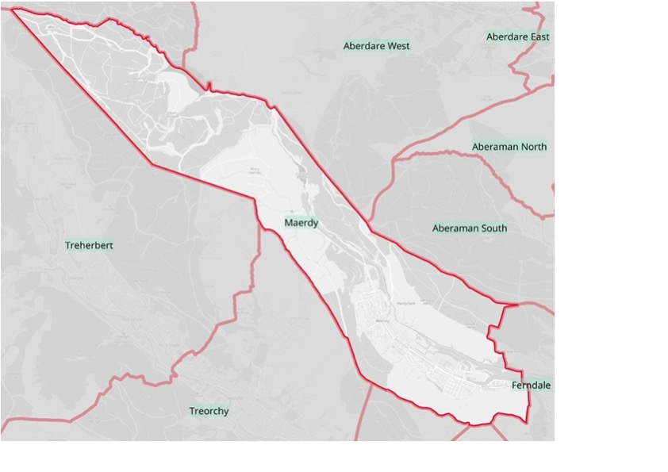

Residents must provide proof of residency at the voting hall. Accepted proofs are:

* driving licence,
* utility bills,
* bank communications,
* local or national government communications e.g. Council tax bill, social security, etc.

Other proofs of residency will be accepted at the discretion of the presiding officer.

Please note passports do not contain an address and therefore cannot be used.

Residents must be aged 15 or over. Young voters must provide proof of age as well as residency at the discretion of the voting officer. If you look young, please ensure you have proof of your age – this is your responsibility.

## Proxy Voting

A proxy voter can only represent one other person, not multiple voters.

If you can’t get to the voting hall on the day you can submit a proxy vote by following these steps:

1. Decide on a proxy voter
2. Email or write to us at least 2 days before the vote advising us of
   1. your name and address;
   2. reason for needing a proxy; and
   3. the name of your proxy voter.
3. Attach with your correspondence to us a copy of your proof of residency eg. utility bill, etc.
4. Give your proxy voter a copy of your letter to us, plus the original proof of residency document.
5. Your proxy visits the voting hall, shows us the documents and votes on your behalf.

Sorry it is complicated, but we need to ensure it is robust.

## Voting

Each resident will be allowed to vote for one grant application in each funding category. So with five different funding categories (£500, £1,000, £2,500, £5,000, £10,000) they will have five different votes. Residents do not have to vote in every category if they do not wish.

# You’ve Been Awarded a Grant

## Award of Grants

Any bid must be supported by at least 5 public votes. This is to ensure a minimum level of community support for any cause.

The bids with the most public votes will be awarded the available grants. For example - if there are five applications in a category and only two grants are available then the two bids with the most votes will be awarded the grant.

There has never been a tie for the last available grant, but should this circumstance arise, the administrators may in their discretion fund an additional grant, or share the grant by the tied applicants.

Please note that while it is the intention that grants will be awarded on the basis of the public vote, the scheme administrators necessarily reserve the right to amend or overrule the award of grants in their absolute discretion should they see this as necessary. This has never happened to date.

## Notice of Winners

The votes will be counted and verified and published the Tuesday after the vote on the Fund website. All applicants will be notified by email of the success or otherwise of their application.

Successful applicants will be issued with the Grant Agreement to sign and return.

## Payment of Grant

The grants will be paid by cheque at an awards ceremony in the new year following the public vote: ie. January or February 2026. The date will be notified in December. The location is usually Maerdy Ex-Serviceman’s Club and it is usually a Friday evening about 5pm-7pm.

It is an important part of the transparent fund process that applicants turn up in person to collect their grant. Recipients will be invited to say some words about their project. The evening will be videoed and broadcast on the Fund Website.

Recipients are invited to bring up to 5 representatives. Refreshments will be provided and the grant cheques are usually distributed by the local MS or MP.

The beneficiary details must correspond to the grant and applicant. Verification checks will necessarily be made to prevent fraud.

Grant monies will be issued based on the estimated cost of the scheme. Money is not paid in arrears after you have been billed as this may require applicants to hold personal funds themselves as working capital which might not be possible. However, you are required to provide all receipts, invoices, and accounts if appropriate, through a system of annual reporting. If any monies are to spent they must be refunded.

## Obligations

It is important that the money is properly spent, as was endorsed by the community in their vote and that there is no fraud or similar problems. Therefore successful applicants must sign a Grant Agreement to receive the monies. This contains reasonable and non-onerous obligations. The standard terms and conditions for the Grant Agreement are on the website. The application form contains a declaration that you have read these and if you were awarded a grant you would be willing to agree to them; so please review the Grant Agreement carefully before applying.

Key terms include:

* You must spend the money as you declared during the application. If you want to vary how the monies are spent you must get the Fund administrator’s approval before hand, which will only be provided at the administrator’s discretion.
* You are also required to provide a written report and accounts annually on progress with your scheme, until the funds are spent and the Fund administrators have advised all obligations are complete. These reports or summaries may be posted on the fund website; they will help the community see how you are getting on with the scheme that they have supported.
* You must support us in visiting you and verifying the project
* You must provide us with a record of your expenditure and provide receipts / invoices for all items making up 90% of the total grant. You should keep proper accounting records to enable an audit trail. You must also support us in making reasonable enquiries to confirm the proper expenditure.
* You must spend the money within 24 months and return unused monies to the Fund. If there is going to be a delay beyond 24 months, which may happen for good reason, then you must get permission from the Fund to delay expenditure.

# Provisions

## Changes

The administrators may at their discretion amend the number of grants available. Every effort has been made to foresee how the fund will work and any issues that may arise. However, changes to the scheme may be necessary during its process and applicants must therefore understand and accept this if they wish to apply. The administrators will seek to keep changes to the scheme to a minimum. Interested parties should review the website for updates and sign up to notifications on social media – see website.

## Legal Notice

Please note that the Fund administrators reserve the right in their absolute discretion to refuse applications and decline grants for whatever reason. Please note that the mode of operation of the scheme as described here and elsewhere is subject to change at the discretion of the Fund administrators without notice. The Fund is under no obligation to any person or organisation as a result of their consideration, application, award, or payment of any grant. Any person or organisation should not proceed with a grant application if unwilling to accept these conditions.

## Fund Administration

The Maerdy Wind Fund is administered by Maerdy Windfarm Community Funds Ltd (MWCF). MWCF is a ‘not for profit’ company that is limited by guarantee. This is the counter party which grantees enter into the Grant Agreement with. MWCF is controlled by Renewable Energy Partnerships Ltd, the developer of Maerdy Windfarm.

MWCF receives its funding from Maerdy Windfarm Ltd (MW) which owns the Maerdy Windfarm. MW is owned by Schroeders Greencoat UK Wind group (https://www.schrodersgreencoat.com/).

# Contact

If you have further queries please check out the website [www.maerdywindfund.co.uk](http://www.maerdywindfund.co.uk) or email [enquiries@maerdywindfund.co.uk](mailto:enquiries@maerdywindfund.co.uk)

Sign up to our social media accounts via the website so that you are aware of developments with the fund and any changes to the guidelines.

Please note that to keep administration costs low and hence the community grants high telephone and postal support is available on special request only.